Papa bear

Billy Bearden

________________________________

“Bad to the Bone”

“Saved by the Blood”

Published by-

2010
“Bad to the Bone”; Saved by the Blood

Copyright 2010 by Billy C. Bearden, All rights reserved

All scripture quoted taken from the New King James version (NKJV) of the Bible unless noted in text.

Pictures of family members provided by author.
Graphic art on cover by_________________________

Contents

Pg.

On Interpretation of Scripture ………………………………………… v- vii
Papa bear’s Foreword …………………………………………………… viii- xii
Panhandle Pictures………………………………………………………… xiii

Old Testament:
Genesis……………………………………………………………………. 1-22
Exodus…………………………………………………………………….. 22-30
Leviticus……………………………………………………………………31-33
Numbers……………………………………………………………………33-36
Deuteronomy……………………………………………………………… 36-44
Joshua………………………………………………………………………44-47
Judges………………………………………………………………………47-48
Ruth………………………………………………………………………...48-49
I Samuel……………………………………………………………………50-53
II Samuel & I,II Kings……………………………………………………. 54-58
I & II Chronicles…………………………………………………………. 59-62
Ezra & Nehemiah…………………………………………………………. 64-67
Esther……………………………………………………………………… 67-70
Job…………………………………………………………………………. 71-73
Psalms………………………………………………………………………73-80
Proverbs…………………………………………………………………… 80-82
Ecclesiastes…………………………………………………………………82-84
Song of Solomon……………………………………………………………84-85
Isaiah……………………………………………………………………… 86-88
Jeremiah……………………………………………………………………..89-90
Lamentations………………………………………………………………...91-93
Ezekiel………………………………………………………………………94-98
Daniel……………………………………………………………………… 99-103
Hosea and Amos……………………………………………………………103-105
Joel and Obediah …………………………………………………………...105-106
Nahum, Habakkuk, Zephaniah, Haggai and Malachi……………………....107-110

New Testament………………………………………………………………111
Israel and Egypt Pictures…………………………………………………….112

Matthew…………………………………………………………………… 113-123
Mark………………………………………………………………………… 123-130
Luke………………………………………………………………………….130-134
John…………………………………………………………………………..134-142
The Acts…………………………………………………………………… 142-148
Romans……………………………………………………………………….148-154
I Corinthians………………………………………………………………….154-164
II Corinthians………………………………………………………………….164-165
Galatians………………………………………………………………………165-168
Ephesians…………………………………………………………………… 169-176
Philippians………………………………………………………………….. 176-178
Colossians…………………………………………………………………… 178-180
I Thessalonians……………………………………………………………… 181-183
II Thessalonians……………………………………………………………….184-186
I Timothy …………………………………………………………………… 186-194
II Timothy …………………………………………………………………… 194-196
Titus …………………………………………………………………………. 196-196
Philemon …………………………………………………………………….. 197-198
Hebrews ………………………………………………………………………198-208
James ………………………………………………………………………….208-211 Peter ………………………………………………………………………… 211-214
II Peter ……………………………………………………………………… 215-217
I John ………………………………………………………………………… 218
2nd and 3rd John ……………………………………………………………… 219
Jude ……………………………………………………………………………220
Revelations …………………………………………………………………….221-224
After Thoughts ……………………………………………………………… 225-226
Basic Bible References by Subject ……………………………………………227- 231
Notes ………………………………………………………………………… 232

On Interpretation of Scripture

In any reading, as with handling the spoken word, one needs to understand the writers or speakers point of reference (his/her background, culture, style, audience and context of the subject). Speaking here primarily of the written word, a writer may write in a very simple and direct manner allowing the reader to interpret the writing in a simple literal fashion without a lot of danger of wrong interpretation. The Bible is certainly not a writing of this nature. It was written, transcribed and translated in a very different time from our modern age. In addition most of the original transcripts were written in Ancient languages of Hebrew, Greek and Aramaic, liberally utilizing metaphors, symbolism, parables, and numerology. While Bible scripture tells us that God is not the author of confusion, given these challenges, one has to be a very astute student to properly handle much of the Bible’s writings and it is quite easy to understand that there are numerous chances for translators throughout history to miss the mark in properly translating original manuscripts or copies of older transcripts. There are even some accusations of factual conflict but careful research will disprove most of these accusations. You will find writers covering the same subject from a different perspective. When all is said and done there is little wonder that modern day readers come away with many differing interpretations that represent confusions of man. We will learn later that such confusion is not of God because His word states that God is not the author of confusion. For this reason it is not surprising that early Roman Catholic Church leaders went to great length for hundreds of years to keep their common members from having access to the scriptures. Not until some years after Martin Luther’s break with Catholicism did the Bible become more accessible to the commoner. They (their Priest) rather interpreted the scripture themselves, reducing the opportunity for the unlearned reader to misinterpret the scripture. Some examples of writings open to different conclusions are Jesus’ use of the parables like, “I am the vine and you are the branches” or “Destroy this temple and I will raise it again in three days.” The listeners in the latter parable thought he was speaking literally of the temple in Jerusalem when in fact He was referring to His bodily resurrection on the third day after crucifixion. On baptism and the plan of salvation, the Gospel of John emphasizes, as did Christ, believe and you will be saved. Repentance or confession is not mentioned in some scriptures nor is baptism; therefore many conclude baptism is not required for salvation despite all Bible examples of individuals being saved participating in the final step of baptism. Also Paul and Peter’s writings on salvation include baptism in most cases. Peter said in one scripture “baptism doth also now save us”. He emphasized “now” because before Christ death, burial and resurrection, baptism had no significance in regard to salvation. It did have a Jewish meaning in the sense that a cleansing with water was called for prior to the priest approaching God on behalf of the Israelites sins. Even John’s baptism had no other significance than “fulfilling all righteousness” by pointing to Christ perfection and ultimate sacrifice on a cross for our sins and salvation. But “now” Peter says, “it does now save us”. The conclusion of the matter is that to properly get to the truth of God’s will for this subject of baptism or any subject, one must look to the sum of God’s word (Psalms 119: 160), “the entirety of your (God’s) word is truth” to come to the truth which scripture tells us, “will set us free”. (John 8:32) Few do that, preferring to select one or two passages and forming their theological conclusions solely on those scriptures and then our divisions begin.

Other Challenges abound:
- As stated above, no subject is covered in any one chapter or verse. To reach proper conclusions of the truth then, one must search the complete Bible to draw conclusions. David in the Psalms expressed it perfectly when he said, “the sum of God’s word are precious.” (Psalms 139:17) You could say that it is impossible to know and understand the entire Bible and it would indeed seem so, considering how little we stay in study of the Bible and how shallow our effort is. There is no wonder why we understand so little and fall for so much misapplication and misinterpretation of scripture spewed from our pulpits.
- If we are to draw sound conclusions from the Bible concerning God’s will, we must handle with care all of these complexities to include “ rightly dividing the Word” as Paul wrote to Timothy. God’s will and way divided on the cross as Christ died there and as the Curtain in the Holy of Holies at the Temple Split from top to bottom in Christ hour of death. The division or splitting of the separating curtain ushered in our access to God through our new High Priest, Christ Jesus. No longer would the Godly man have to depend upon a carnal Priest to intervene on man’s behalf with God. We today can penetrate the split curtain and have fellowship with our God directly with Christ’s authority if we accept Christ as our Lord. Much of our error and division today occur when we fail to “rightfully divide God’s word” and fail to understand that things changed on the cross.

- No one Person, especially this writer, can claim to have it all right. It is a growing process of the highest order for us all. The best we can do is study prayerfully asking for guidance of the Holy Spirit and wisdom as we form our conclusions. I Peter 3:15 tells Christians, “Always be prepared to give an answer to everyone who ask you to give a reason for the hope that is within you.” Papa bear would add, be bold in defending God’s Word and His truths. Our faith in God’s Word is being attacked openly and unashamedly in these modern times. Atheists boldly declare that there cannot be two truths about reality of life and they are totally right. One has to be true and the other false. The Atheist then boldly declares that our God is a figment of our imaginations and scientific explanations hold the truth of our world. They reject unapologetically the truths of God’s Word. We can and should be just as bold as they in defending our faith as long as we have a solid background in the study of God’s will. Be prepared. There is a battle going on in this world and we must be able to defend God’s word at every turn.

Read and study His word, properly dividing His truths and forming conclusions based on the sum of God’s word using our God given intellect (Heart) and logic.

- On logic, here is an example. Read Acts 8: 26-39 in a reference to the conversion of the Ethiopian Eunuch. We find that the Spirit leads Phillip to join with a traveling Ethiopian who is reading Isaiah 53, a prophetic scripture about the Christ. Phillip ask him if he understands what he is reading to which the Eunuch responds “How can I unless someone teach me?” Phillip then commences to teach him “Jesus”. The question for us should be, “What does one teach when one teaches Jesus to one who is desirous of knowing the plan of God/Jesus to redeem his soul?” We are not given every word Phillip said to the man. How can we find out what he taught regarding what the Eunuch must do to be saved “in Jesus”? First listen to what the Eunuch asked of Phillip after Phillip taught him Jesus, that is, tells him how one is saved in Jesus. The Eunuch sees water and asks at verse 36, “See here is water. What hinders me from being baptized?” Phillip answers him, “If you believe with all your heart, you may.” The Eunuch said, “ I believe that Jesus Christ is the Son of God.”(This is a confession of faith (belief) in Jesus as the Christ). So he commanded the chariot to stand still and both Phillip and the eunuch went down into the water, and he baptized him. When they came up out of the water, the spirit caught Phillip away and the eunuch saw Phillip no more; and he went on his way rejoicing after baptism. Bring on the logic please. Why did the eunuch show such interest in being baptized? Would not logic lead you to believe that to teach salvation through Jesus, Phillip must have emphasized baptism as a final step after believing and confessing Jesus as the Christ. Why else would the Eunuch seeing water ask such a question? You might also say, “Hey I didn’t here him repent of his sin?” No you did not, but would not ones logic also knowing that other scripture mentions repentance as necessary cause you to conclude that Peter also taught repentance of sin. Why was it not mentioned? Can we not again use logic to conclude that Phillip would have taught repentance at some point? If so, then the Eunuch’s sincere desire to follow Phillips teachings by being finally baptized, led Phillip to conclude and should lead us to conclude that the Eunuch had accepted Christ (confessed Him as Lord) and repented of Sin, even if not verbally. Lets face it, not all items called for in different scripture referencing salvation are mentioned in one scripture. But in every recorded incident of a person accepting Christ as their redeemer their concluding act is baptism. Look to each scripture in “Basic Bible References” (Conversion, Examples of) and see baptism as the final act in each occurrence. To include belief, confession, and repentance and conveniently leave off baptism as a necessary thing is being a bit disingenuous and illogical. When you think about it one could conclude that one has a repentant heart without any physical or vocal response. A confirming confession of Christ as Lord would be a little harder to discern without verbalization, but not impossible. Baptism on the other hand requires a physical action, an action that will not be accomplished unless God has truly worked on ones heart. It is a humiliating act and often not convenient. It’s a work of God on ones heart and a physical act of obedience, a witness of faith for the saved. For the belief only crowd and their “mantra” that since salvation is free we do not have to complete the work of baptism; baptism is not our work but a work of God on our heart bringing us to obedience. Is it required? A complete study suggests baptism as an inseparable part of your belief, faith, and your salvation. Baptism testifies to your faith in Christ death, burial, and resurrection and is a physical picture of it. But is it necessary? God’s word suggests yes, but it’s up to Him isn’t it. We will let God answer that on our last day. Knowing all that I have studied, if it was feasible to accomplish immediately after my believing in Christ, I would not bet my souls redemption on neglecting baptism. If one dies before reaching the baptizing water, is he saved? Or if one dies on the deathbed or battlefield before or because baptism by immersion could not be accomplished, is one saved? These are favorite entrapment questions of religionist who whish to challenge the idea of baptism as a part of salvation. We will discuss God’s foreknowledge of what act of obedience we would do if we were physically able. Have faith in God to know the heart of one in this position whether he/she would obey God’s will if they had the opportunity to accomplish the act of baptism. God can save whom he wishes. What do you think?

- Interpreting scripture properly surely requires a healthy dose of logic and common sense. God does not waste a lot of words on us mere humans and he certainly expects us to use our God given intellectual logic, our spiritual soul, His Holy Spirit, to completely understand His will and word. As John said, “I suppose if everything Christ did (or John could have said, “Stated”) were written, the world would not hold the books”. (Parenthetical statement added by author).

Your critical discussion of what follows is encouraged and may God bless you for it.

Papa Bear’s
Forewords

This is written first for My Grandchildren.
If any other find it helpful, bless you.

This writing is a result of 45 years of Bible study with intense study the past two years, 2008-2010 by Papa Bear with Granny Esther beside me studying together and offering support and yes, her engaging challenge to my understanding. Her challenges and support were appreciated and incorporated many times. Nevertheless I am left with the sole responsibility of claiming all of what follows. I fully expect that Esther, you and others will disagree with many of the conclusions herein even counting my convictions as arrogance at times. One thing for sure, Papa Bear’s understanding of God’s Word and His will has evolved over years and continues to evolve. In fact, it has taken much longer, more like 59 years of exposure to God’s Word, to form this work.
I suppose my religious upbringing began in the early 1940’s when the Bearden family of Great- Great Grandpa, Pappy Bearden, and Great Grandpa Clayton Bearden, Grandfather Willie Bearden and Father Willie Ocile Bearden settled in what we called “the Panhandle of Dallas and Perry Counties, Alabama. They farmed some 300 acres of land there until around 1946 growing every thing imaginable, mainly to feed the family and perhaps trade for more durable goods bought principally off what we affectionately called “The rolling store”, a rickety old bus, which delivered commodities once per week from Selma, AL. It was an exciting adventure for us kids (Aunts Clara, Shirley and me, Billy) to sit on a red clay bank waiting to hear the far off horn of the approaching rolling store coming down the old graveled road from Selma, AL. What a treat it would be if we could convince Grandma (Mama) to let us buy or trade a chicken or some home made cane syrup for a few sticks of striped candy or maybe a little vanilla flavoring for the fresh warm cows milk we had every morning with our fresh sugar butter biscuits cooked in an old wood stove oven. This was a time during and soon after WWII when commodities were scarce so the family had to scrap to live, not unlike others all around us. There was little money but farmers probably had it better than many city dwellers in that there was plenty to eat and trade for staples. I can remember hearing stories of how kinfolk from Birmingham would show up at our doorsteps on weekends looking for something to eat out of our huge garden. There was no electricity and the refrigerator was the water well out back where we would let our milk and other perishables down into the well in a bucket to keep it cool and unspoiled. The same well watered the mules, as Dad and Pa Paw would bring the mules in from a hard day plowing. Your bathroom was a tub of water on the back porch and the toilet was a long cold walk in the backyard where many a varmint roamed and the Sears catalog was your slick toilet tissue and casual reading all in one. Entertainment consisted of sitting on the sprawling front porch in the evening listening to the whippoorwill and hoot owls in the surrounding wood- lands. As we got older, I remember and cherish the hours we spent on the front porch harmonizing any
song that came to mind. All you had to do was start it and the whole family knew it and immediately joined in perfect harmony. If there was anything our family was noted for it was, “That family can sing”. I was never sure if we really were that good at singing but there was never a doubt we loved to sing.
There was a small community of families in the Panhandle and Medline Baptist Church and Fellowship Baptist, both a 4-mile wagon ride away, were our two church congregations of the area. They served us spiritually and for most adults in the community represented the larger part of their educational background. Let me tell you if there was nothing else in your educational background other than years of Bible study and reading and writing, one could get along pretty well in the first half of the last century, at least in Perry County Alabama.
I shall never forget lying on a homemade quilt in the back of a mule pulled wagon looking up at the stars as we rumbled down the dirt road back home after Wednesday night Prayer meeting. Pa paw had an old car but we had to save rationed gas for going to town for business reasons. Great Grandpa Clayton had a fancy horse buggy but just he and Grandma rode in that so our old work wagon pulled double duty for the rest of the family. Grandpa Bearden, who died at the early age of 48,was the song leader for Medline Church at the time so we rarely ever missed a service. About this time Dad was off to Japan in World War II so Pa Paw was my only male mentor. This had to be the beginning of my exposure to spiritual life balanced with our physical needs. Both were nurtured carefully for in such a stark environment, life was a balancing act between the Physical and the Spiritual realities of life. One had a complete understanding in these backwoods that God or some powerful manipulator of nature had control of our lives and we needed all the help we could get to live. Later, just before I and two of my Aunts who were near the same age were to begin school, we moved to Dallas County, Plantersville, AL. Quite a move up in the world, all of 9 miles, but what a change in environment and a long move as far as we kids were concerned. There was electricity in the form of a single light bulb strung from the ceiling now instead of kerosene lamps and there were real stores to replace rolling ones. I can’t recall exactly but I believe there was at least one slag paved road in town. A railroad ran rite smack through the middle of town spewing burnt coal dust and smelling up every thing with its distinctive smell. What a deal! Still no running water or indoor toilets till the early 50s. The Plantersville Baptist Church, eventually next door to our home, became our new church home and it was here at age 9 I first believed in Christ as my Savior and was baptized (immersed) in Mulberry creek along with a group of other believers, scared to death after a Hell fire and Brimstone preacher came to town for our annual revival. I’ll never forget, he drove a big white Cadillac and wore a white sport coat and white buck shoes and I do believe he wore a big diamond on his hand and slicked back hair, kind of like a rock star. My Baptism, I later found out, sixteen years later from the Baptist preacher who baptized me, was not for the remission of sin but was symbolic only and showed that “in good faith” I had been accepted into the “Plantersville Baptist Church” as a Baptist. I was saved the moment I believed, he informed me. Well, I was not so concerned about being “in the Baptist Church of Plantersville” so much as I wanted a ticket to Heaven by being “in Christ”.

I supposed it had all happened in accordance to what the preacher said was God’s Will and that was good enough at nine years of age but I had a lot of thinking to do.
In my early twenties after finally spending some time in studying the Bible, I learned from my study of God’s Word that one who was saved by the blood of Christ sacrifice would have necessarily, after believing, been baptized as a last step “into Christ”. Baptism then meant much more than this preacher suggested and should not have occurred after supposed salvation but before. My preacher “got the cart before the horse.” Before learning what the true way to salvation was, I will have to tell you, other than continuing to attend worship three times a week in my teenage years, I would not say I had a lot of in depth study of God’s word. Exposure; yes, study, no. My Mother, Lula Dee (Mama Dee to the grand kids), made sure there was plenty of exposure by going to church but I do not remember a lot of study on my part, in the home or church. Church as far as I could tell at that stage of my life was for social fun and camaraderie and if attendance would save me, I was surely saved.
I went on to College at Auburn and my attendance and study of the Bible there were ashamedly, non- existent frankly. Not really having a good background in studying God’s plan for us, I began as most probably do, making big decisions without God’s input. Decisions such as my first real licensed marriage (you’ll understand this highlighted term later) and career choices were the biggest decisions I made on my own. Most of these decisions were without a firm knowledge of God’s Will; I’ll have to say. I would not recommend this approach to any young person but I am not naïve in this regard. Most people certainly can relate to the error of neglecting God’s Will in their life and realize there is a cost. There are few who seeks God’s leadership in their life decisions so it’s no wonder our lives or so messed up. Papa Bear has made many mistakes in life and they all hurt him and those around him. I have one plea to all that are dear to me. Please do not neglect your study of God’s Word and seek his guidance in your life’s decisions always and exercise patience in waiting on God’s guidance. Begin early and, I beg you personally to do your own study and don’t rely totally on someone else’s study and conclusions including conclusions I may make herein. Prove through God’s Word all that you are taught if it be true or not. To those I hurt in my sin and decisions, I beg for your forgiveness.
Let me also so express to my Children and their Mother these words. I am nearly certain that my first marriage to your Mother was not of God’s Will but can say without a doubt; God used that decision, mistake or not, in a most glorious way. He gave us two wonderful sons whom we love dearly and your mother was a dear and loving mother not without problems of her own. But God in however way He used that union, provided me with the most precious inheritance I shall ever have and that is exposure and acceptance into the Lord’s true Church, the church of Christ as Paul called it. The earthly church body by that name is imperfect and evolving, however it represents to me the closest religious body on this earth today to being the church that Christ died for and described in New Testament scripture. Its charter has been from its inception to “restore” Christ Church to its intended Glory and abhors any attempt to “reform” or rebuild any other body than the one described in New Testament Scriptures. I must say I identify with this body knowing full well that there will be many who will throw this book as far as they can because they truly hate the church of Christ.

I do understand Peter’s reluctance to identify himself as one of those with Christ. To admit it, one risks no small amount of criticism. I remember one close family member telling me “you always did tend to be weak and follow anybody that came along.” That was a mean spirited hurtful statement rejecting the fact that I had the audacity to join another Church other than the one I was brought up in. That of course hurts, but as a family in Love, we get over it. Let me say once again; the group calling itself The Church of Christ has over the years shot itself in the foot on more than one occasion as it portrays its understanding of God’s Word in what many consider to be arrogant and an unloving way. Much of this stems from the Churches effort to speak where the Bible Speaks and be silent where it does not speak to a subject. They make special effort to use Bible expression for Bible subjects, to answer questions with the sum of God’s Word refraining from settling on an answer based on one or two favorite writers. Finally they catch a lot of grief as they boldly and unapologetically take a stance on all scriptural based answers. This boldness, while it answers Paul’s admonishment of Timothy to be bold in his handling of the word and dealings with teachers of error, causes hard feelings of those who reject this approach and perhaps the truth. There are individual congregations of Churches of Christ today who stand on decisions of theology, which are from a scriptural standpoint, questionable in light of God’s Word. There will never be absolute perfection in any congregational body as men attempt to lead just as we are not without mistakes and sin as Christians in our individual lives. There are invariably other possible missteps in regard to this group but once again I will say the Churches of Christ to my knowledge and experience comes closer than any other body to the one true Church mentioned in the New Testament. It is acknowledged that the very idea that there is “one true Church which Christ died for” is foreign to most of the religious world today save three bodies possibly; the Roman Catholic Church, Greek Orthodox Church and the Church of Christ. The rest pretty much hold the line, “It doesn’t matter where you attend as long as you attend”. Any church congregation will do. TV preachers will say attend the church of your choice, that is, do your own thing. When there was no King in Israel Judges 17: 6, “everyone did what was right in their own eyes”, and look at their catastrophic results. I defy anyone to put together a complete sum of God’s word in a study and come away with the conclusion that God accepts the conclusion that any old way will do in following or worshipping God. And the world says, “Well that’s a little arrogant in itself.” So it is what it is.
What you read here are simply my own conclusions based on my prayerful study of God’s Word. Most that diligently study God’s Word over time will tell you that we learn something new in our study each time we open our Bible. Our understanding grows and changes over time, which I suppose is a direct action of the Holy Spirit of God that is buried within His word and His word is living as His Holy Spirit. You can be sure God’s word never changes but no doubt we do physically and mentally change (evolve) and hopefully so does our knowledge of God’s will. I guarantee you that within a day after publishing a limited edition of this little book I will regret having espoused some conclusion made herein, wishing I could change it. Sadly, that may not be possible in my lifetime and I will have to ask here and now for God’s and your kind forgiveness where I err. To my children and grandchildren, do your own study and take responsibility for your own conclusions.

I can only pray that some of what is discussed herein will be useful in your journey. In their walk I hereby give any of my children or children in their line my permission to correct or add to and republish this writing giving due diligence to the sum and truth of God’s word and so long as they are “in Christ church”. What I mean by “in
Christ church” is The church that you, my children, after careful and complete study of God’s word have determined to be that Church described in New Testament Scripture, especially in its faithfulness to name, items of worship, salvation and Love. In your life’s walk, seek continually the Church Christ died to establish which is only depicted in the Bible, specifically the New Testament scriptures and prophesied in the Old Testament. Avoid if you can any assembly that is not trying to “restore” the one “true Church of God” and know that there is “only one church” and not many as the world will have you believe. If you do not buy that idea, find one example in scripture, which refers to multiple churches. You will find Paul greeting the several congregations of the church but never will you find the word “church” as an entity used in the plural sense.
Prefer the company of those who earnestly seek God and feed their spiritual selves daily on His word. That does not mean to avoid those who don’t. We must live in this world and until Christ returns we must interact with all men. Otherwise, how could we fulfill Christ Great Commission for His disciples to go unto the entire world and teach others? You cannot do this and not live in the world. You can and must live a life that is balanced and “in Christ” while trying to avoid life’s sinful traps. May God bless your efforts and know you will never be perfect except “ in Christ”. What must I do to be saved, to be “in Christ”? That is the most important question mankind or you will ever ask. It is the single question this writing sets out to answer and it is hoped that will be accomplished.
May God help you to understand and accept the guidance provided and help you to prove to your satisfaction the truth of your own conclusions.

God Bless you.

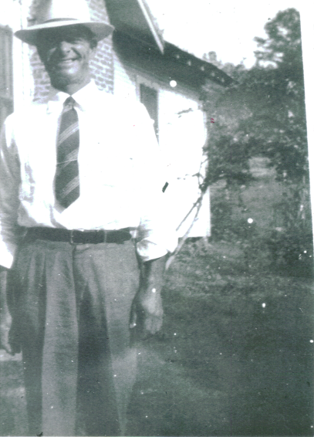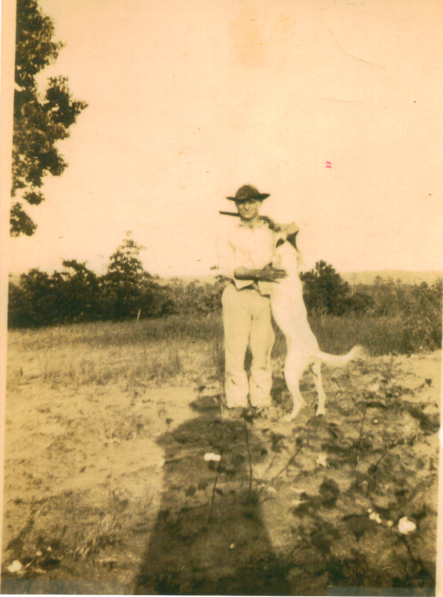
Papaw/Willie Bearden Papaw/Willie Bearden and his favorite Bird Dog

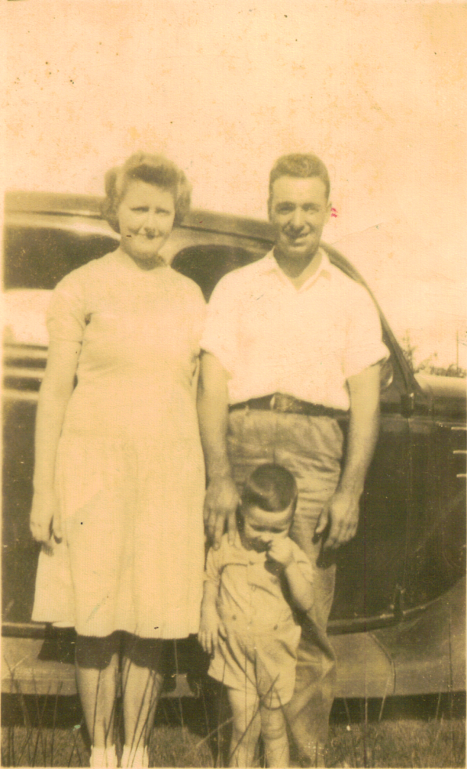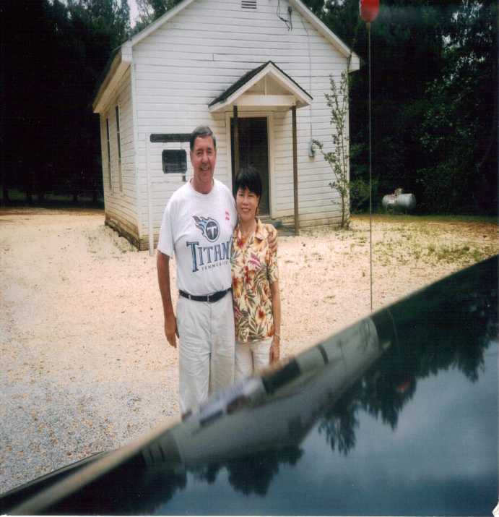
Mom/Lula Dee, Dad/ Ocile Bearden & Billy Bearden Old Medline Baptist, Papa bear &Esther

